## Automated ELK Stack Deployment

The files in this repository were used to configure the network depicted below.

C:\Users\Funny\OneDrive\Desktop\MTK2021CyberNW Lab Dec

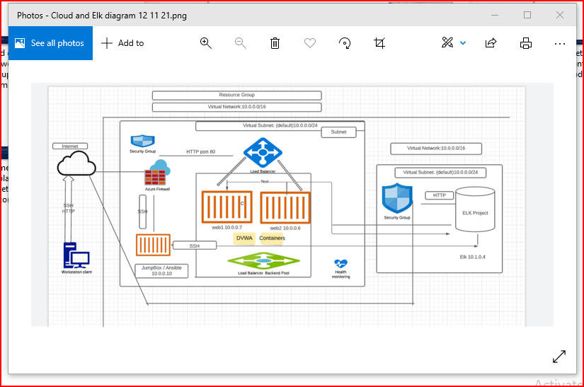

These files have been tested and used to generate a live ELK deployment on Azure. They can be used to either recreate the entire deployment pictured above. Alternatively, select portions of the playbook file may be used to install only certain pieces of it, such as Filebeat.

Playbook file:

This document contains the following details:
Network topology below is a visual display of the connections of the computer network, specifically for the project of ElkStackCybersecurity-Northwestern University.

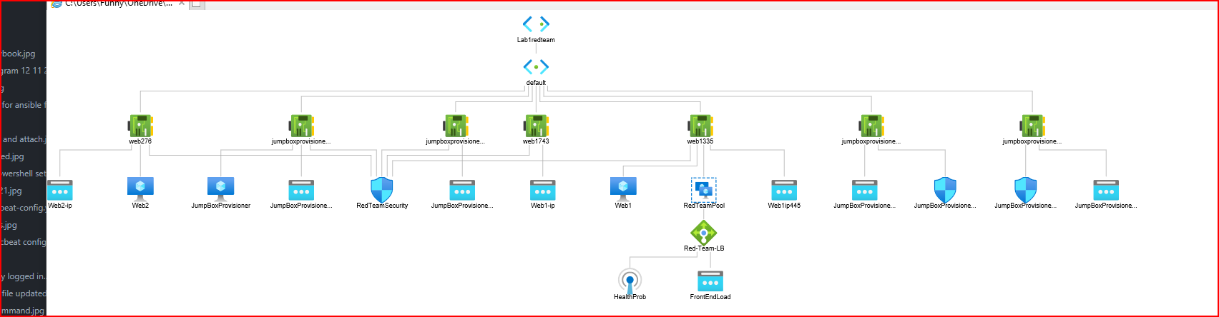

- Access Policies
- ELK Configuration
- Beats in Use
- Machines Being Monitored
- How to Use the Ansible Build

### Description of the Topology
The main purpose of this network is to expose a load-balanced and monitored instance of DVWA, the D*mn Vulnerable Web Application.

Load balancing ensures that the application will be highly available, in addition to restricting access to the network.

What aspect of security do load balancers protect?
Load balancers add additional layers of security to website – without having to make changes to the application. They protect applications from emerging threats. The Firewall – in the load balancer – protects from website hackers and virus scanners.

What is the advantage of a jump box?_
Protects a critical system
A jump box is simply a system, usually a single operating system
Easy to upgrade
Reliability and ease of customization

Integrating an ELK server allows users to easily monitor the vulnerable VMs for changes to the log file and system metrics.

What does Filebeat watch for?_Log files
What does Metricbeat record?_Metrics

The configuration details of each machine may be found below.
Markdown Table:
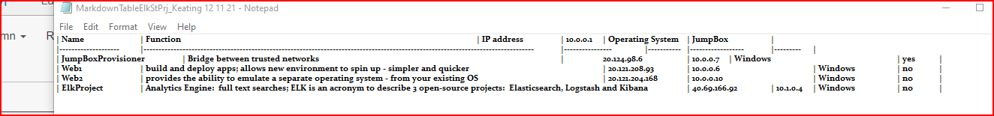

### Access Policies

The machines on the internal network are not exposed to the public Internet.

Only the JumpBox machine can accept connections from the Internet. Access to this machine is only allowed from the following IP addresses:

Add whitelisted IP addresses:
Jumpbox Provisioner

IP whitelisting is used to grant network access only to certain IP addresses. While this has been used as a security measure, it does have its drawbacks. First of all, IP addresses are not constant and can change often. Second, IP addresses can be spoofed using a VPN and can cause your network to become less secure.

Machines within the network can only be accessed by SSH to the JumpBox 10.0.0.7.

Which machine did you allow to access your ELK VM?
DVWA Container
Filebeat
Metricbeat

What was its IP address?_ HomeIP

A summary of the access policies in place can be found in the table below.

| Name | Publicly Accessible | Allowed IP Addresses
| JumpBox | No (yes during execution) | HomeIP |
| Web1 VM | No (yes during execution) | 10.0.0.7 & HomeIP |
| Web2 VM | No (yes during execution) | 10.0.0.6 & HomeIP |
| ElkProject | No (yes during execution) | 10.0.0.4 & HomeIP |

The network is set up with a load-balance which monitored instances of DVWA, Vulnerable Web Application. Load balancing ensures that the application will be highly available, in addition to restricting access to the network. Load balancing is effective at preventing DDoS attacks.

### Elk Configuration
Ansible was used to automate configuration of the ELK machine. No configuration was performed manually, which is advantageous because:

Automation is time consuming; it streamlines connectivity and eliminates setting errors.

What is the main advantage of automating configuration with Ansible?
Open-source automation and configuration – tool to manage which improves the scalability, reliability, and consistency of the IT environment.

The playbook implements the following tasks:
In 3-5 bullets, explain the steps of the ELK installation play. E.g., install Docker; download image; etc._

  - Installs docker python module
  - Installs memory to max
  - Launches the docker Elk container after download

![ Update the path with the name of your screenshot of docker ps

C:\Users\Funny\OneDrive\Desktop\MTK2021CyberNW Lab Dec\ElkProject1\docker ps command

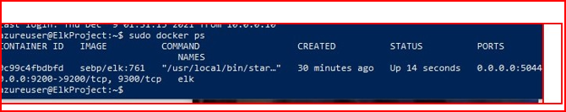

### Target Machines & Beats
This ELK server is configured to monitor the following machines:
Web1 VM 10.0.0.7
Web2 VM 10.0.0.6
ElkProject 10.0.0.4

We have installed the following Beats on these machines:
- Filebeat -
- Metricbeat

These Beats allow us to collect the following information from each machine:
Filebeat: Tool to collect, forward and centralize data logs
Defined parameters – collects log events – forwards to Elasticsearch or Logstash for indexing

Metricbeat: Tool to collect system and application metrics – send the data to Elasticsearch: examples of system metrics: CPU, Memory, Disk and Network Stats (IOPS)

### Using the Playbook
In order to use the playbook, you will need to have an Ansible control node already configured. Assuming you have such a control node provisioned:

SSH into the control node and follow the steps below:
- Copy the configuration file to etc/ansible.
- Update the host file to include the private IP address of the Elk machine.
- Run the playbook, and navigate to Kibana to check that the installation worked as expected.

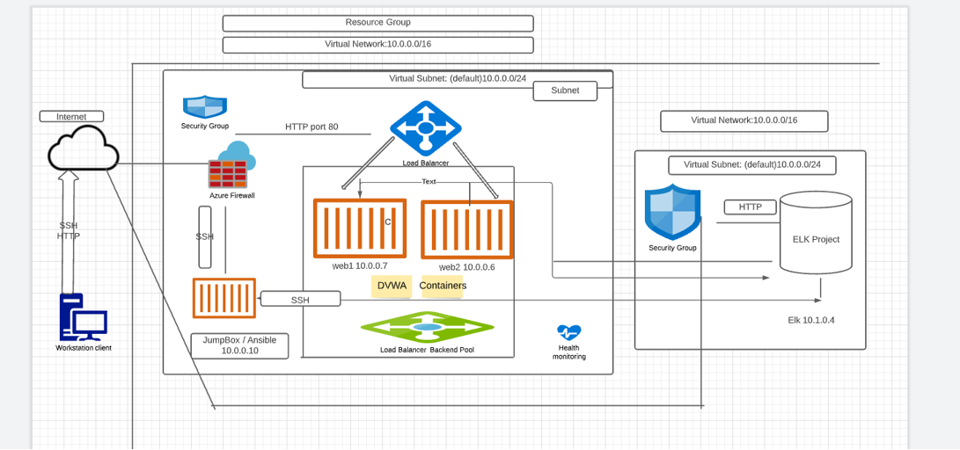

Answer the following questions to fill in the blanks:_
- Which file is the playbook? etc/ansible directory - within the container.
- Where do you copy it? The host file in directory etc/ansible
- Which file do you update to make Ansible run the playbook on a specific machine?
- How do I specify which machine to install the ELK server on versus which to install Filebeat on?_ use the private IP address
- Which URL do you navigate to in order to check that the ELK server is running? myIP/kibana/home

Myip:5601/app/kibana



_As a **Bonus**, provide the specific commands the user will need to run to download the playbook, update the files, etc._

- in root of the container /etc/ansible#
sudo apt update
sudo apt install ansible

nano hosts
nano playbook2.yml
ansible-playbook playbook2.yml

